**LP PAGE 1 (Test on Edge Browser)**

**1.Verify the Header-**

(a) Logo should redirect to the correct link.

Logo link is not redirected to the correct link.

(b) Logo link should open in a new tab.

Request a demo button is working and button color is not correct as per the other buttons.

In header Resource Center button color is not correct and logo or link is not working.

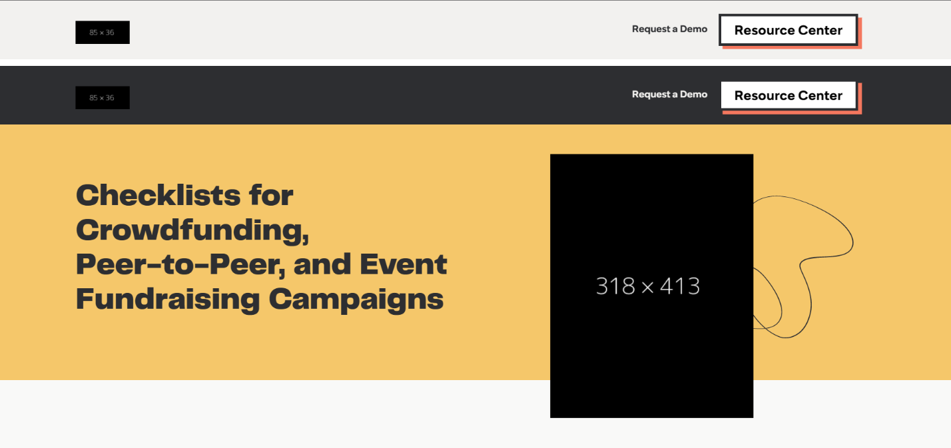

**2.Verify the Footer-**

(a) Verify redirection of Links and content.

Not Working when we click on each link, they go to the current page only. Not redirected to the correct link or not redirected to the new link or new tab.

(b) Verify social icons' redirection.

All the social icons are working properly but not redirected to the new tab or new link.

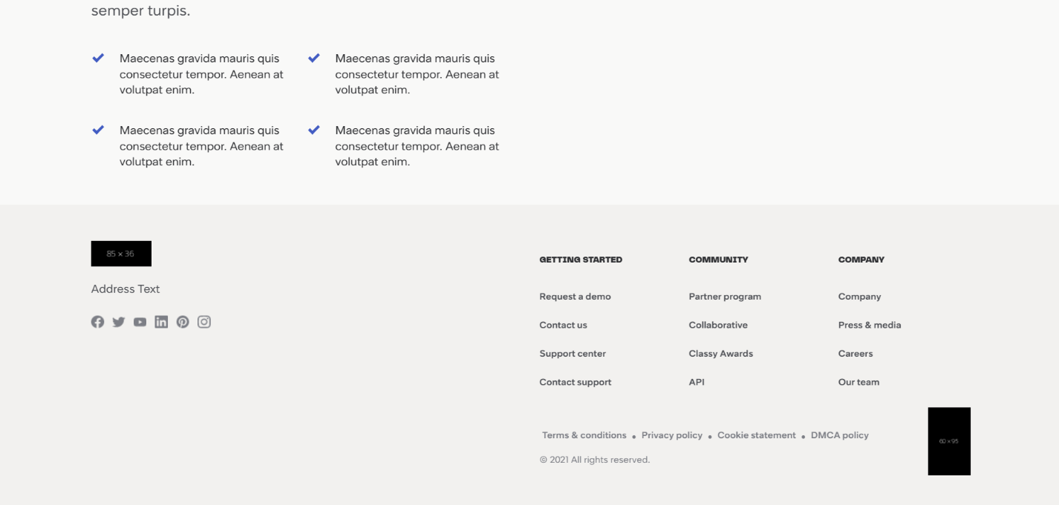

**3.Verify Correct Favicon- Favicon should be the same as it is on the client's live website.**

No Favicon icon is there.

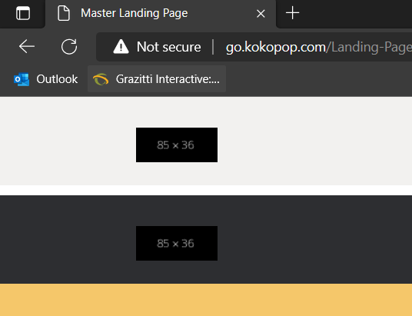

**4.Verify the Font-family- Verify font family is consistent throughout(unless special   requirement by client).**

Header or Heading size is correct but Content size is quite bigger or in some paragraph the font size of one para is bigger than the other paragraph, which is less attracting the page.

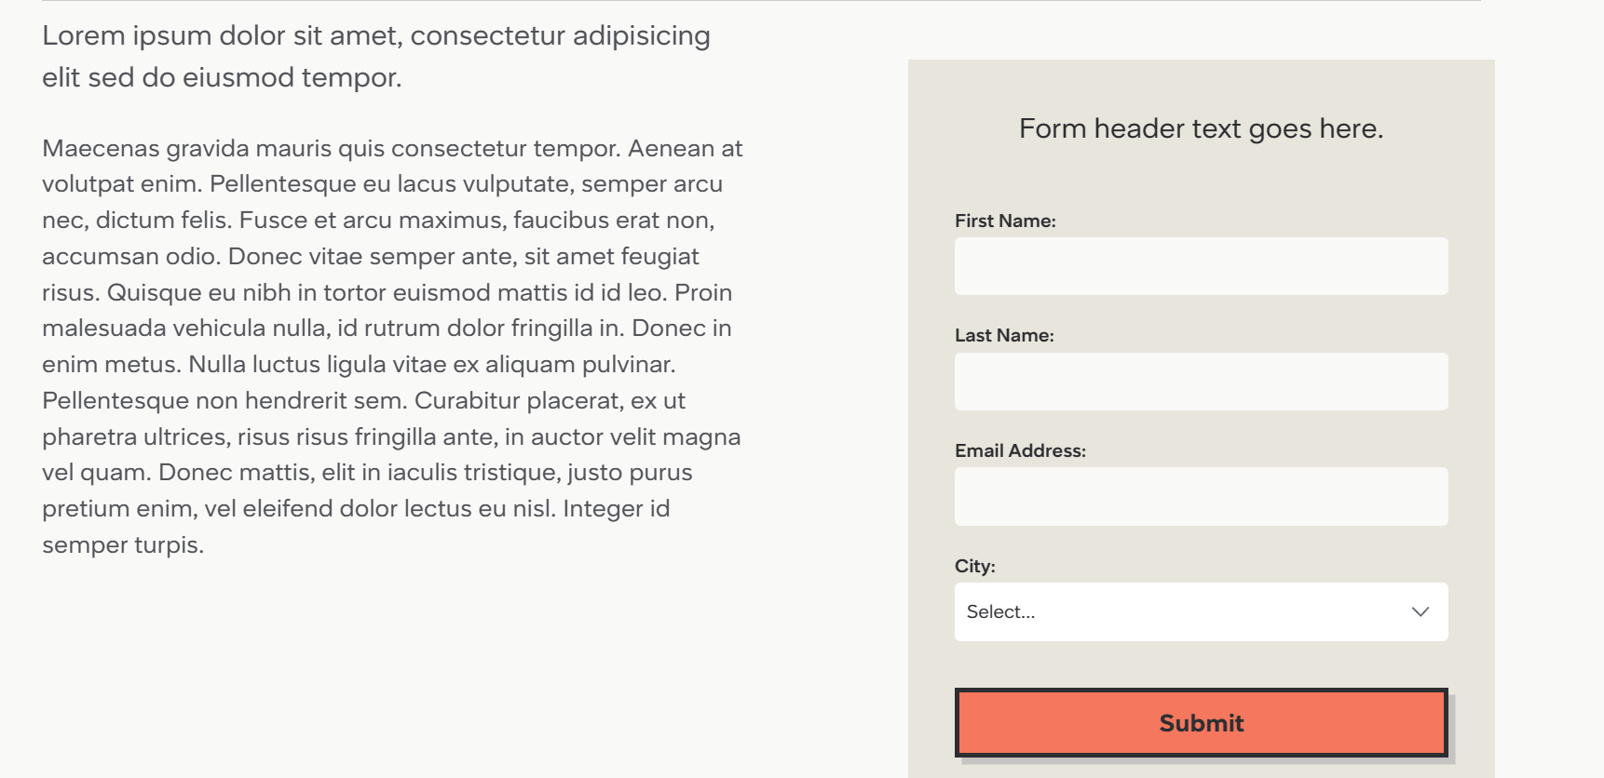

**5.Verify the redirection of links-**

(a) All CTAs, links and icons should redirect to correct pages.

All links is not redirected to the other pages, and buttons and icons also not redirected. And all of these is not opening in new tab.

(b) Add note to developer if # is used for links.

All buttons in the given page contain # in the link at the last. So, remove the # from the last of the link for every button, content and CTA.

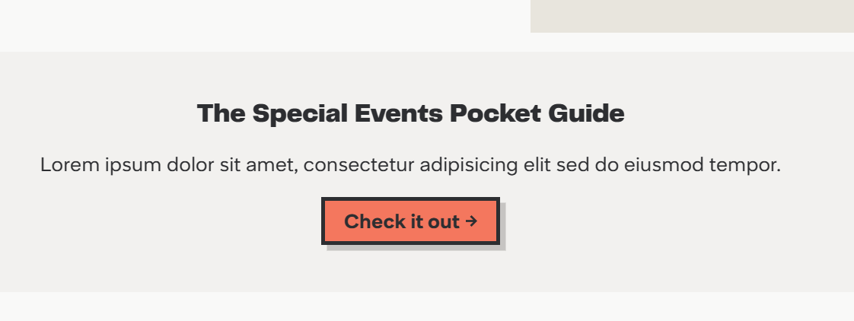

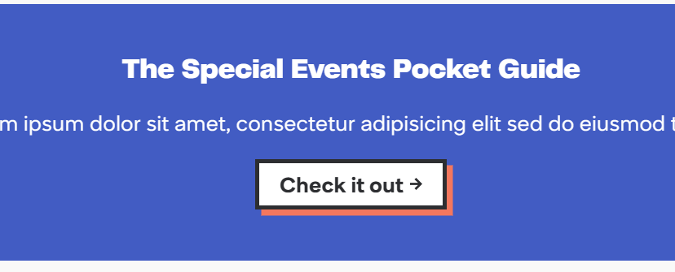

**6.Verify the Spacing - Verify Spacing and alignment of the page should not break.**

In the given screen shots, the spacing is not correct. In screenshot 2 the picture is overlapping on the banner of the front page.

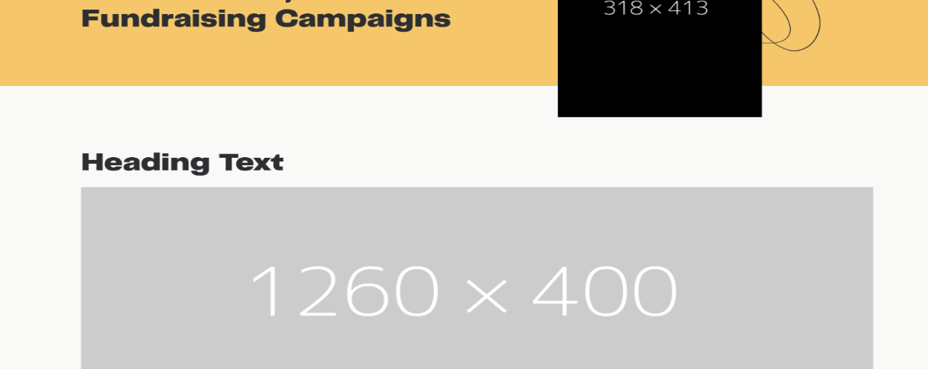

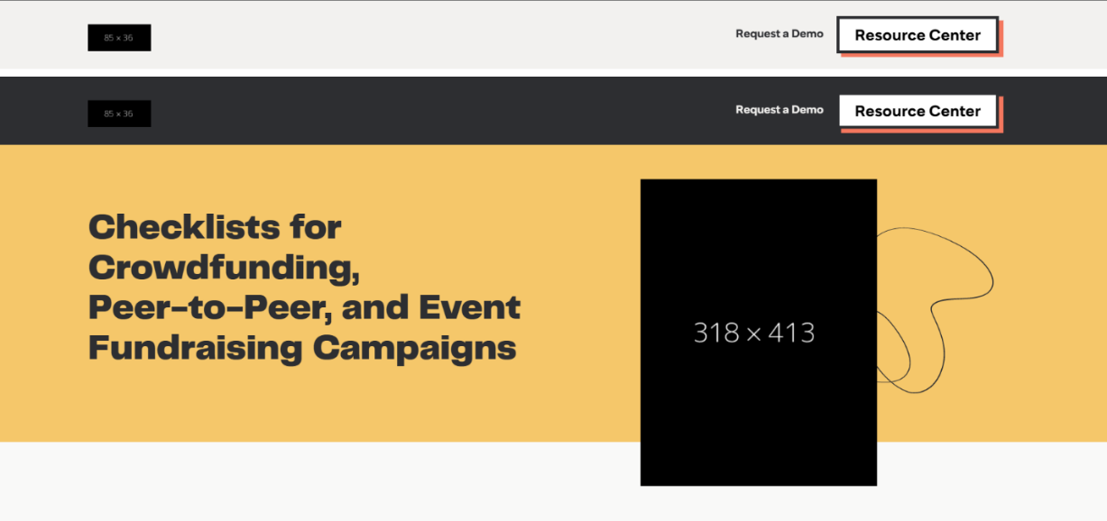

In this screenshot there is too much spacing on right hand side of the webpage.

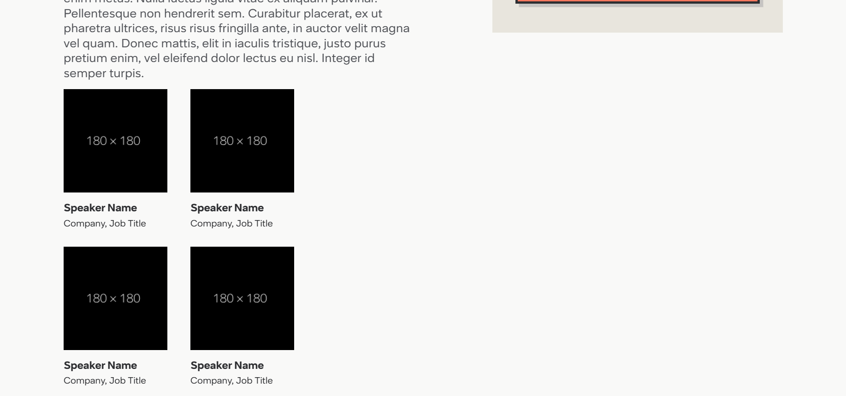

In this picture the header and the paragraph spacing is too much, which is not showing good.

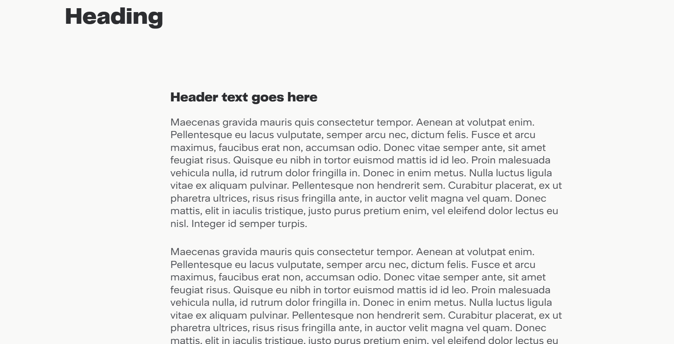

In this screen shot also too much spacing is there.

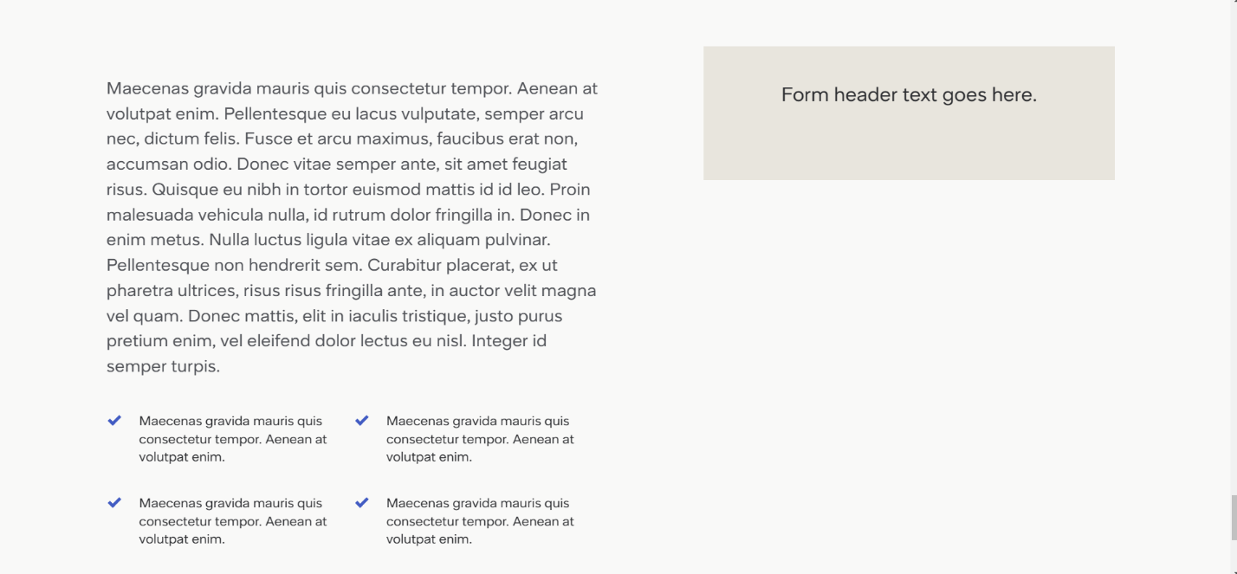

**7.Verify Form-**

(a) Verify alignment and spacing of form.

Alignment and Spacing of the form are correct.

(b) Verify * is used for Mandatory Fields.

* Is not Mandatory field for the given form.

(c) Verify it is showing correct error messages.

Not showing any error messages.

**8.Verify Thank you message after submitting form- If Required.**

When we click on SUBMIT button, there is no message as like Thank you.

**9.Verify Landing page on cross browsers- Google Chrome, Firefox, Internet Explorer and MAC (Safari).**

Working in Google, Chrome, Edge and Firebox

**10.Verify Responsive- Verify it on iPhone and iPad on simulator or live device.**

On iPhone simulator showing- No result found.